HIRING PROCESS ANALYTICS

By SHRADDHA DEORI

I took the help of Excel functions for the analysis of the dataset provided, during which I understood the use of “countif” function and also the use of pivot tables for creation of class intervals table.

1. **Hiring:** Process of intaking of people into an organization for different kinds of positions.   
   **Your task:** How many males and females are Hired ?

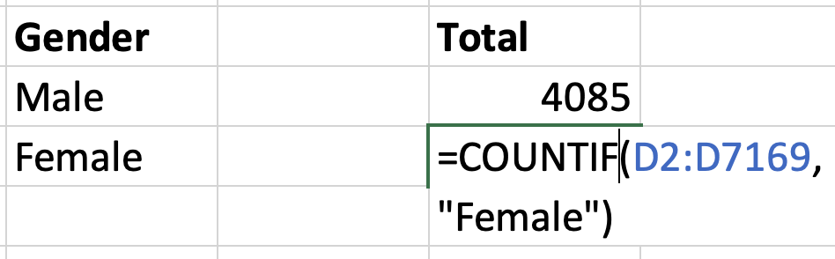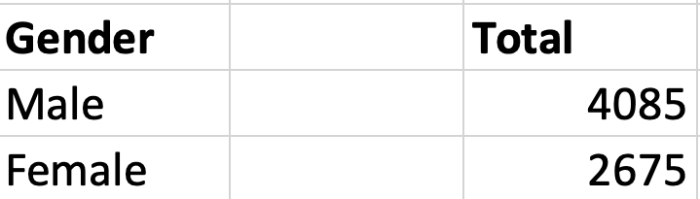

1. **Average Salary:** Adding all the salaries for a select group of employees and then dividing the sum by the number of employees in the group.   
   **Your task:** What is the average salary offered in this company ? 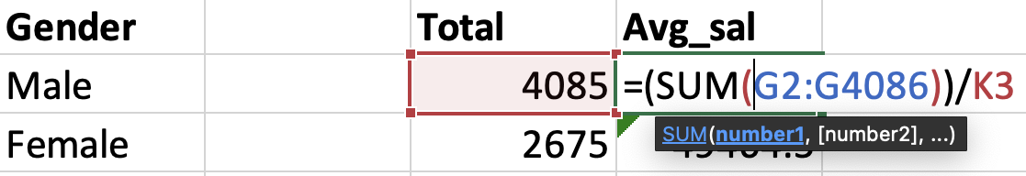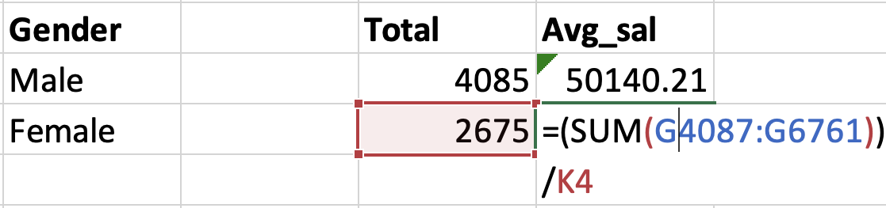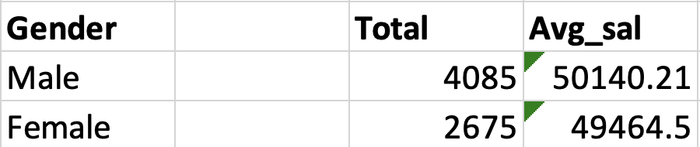
2. **Class Intervals:** The class interval is the difference between the upper class limit and the lower class limit.   
   **Your task:**Draw the class intervals for salary in the company ? 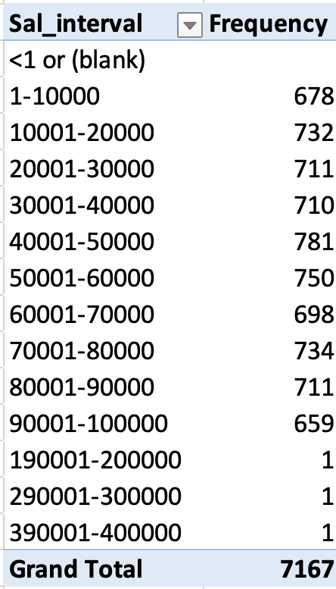
3. **Charts and Plots:**This is one of the most important part of analysis to visualize the data.   
   **Your task:**Draw Pie Chart / Bar Graph ( or any other graph ) to show proportion of people working different department ?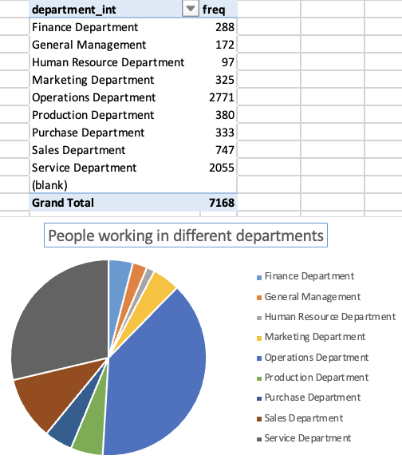
4. **Charts:**Use different charts and graphs to perform the task representing the data.   
   **Your task:**Represent different post tiers using chart/graph? 